Grade 7 Accelerated · Unit 4 · Lesson 4  Real-World Problems and Significant Digits  Question Bank 4.04 | Name______________________  Date______________________  Period____________________

Show your work. Circle your final answer.
For questions 1 through 4, give the number of significant digits in each measurement.
1. 4,207 grams

2. 0.0058 meters

3. 3.200 seconds

4. 52,000 litres

For questions 5 through 8, solve. Report each answer with the correct precision.
5. A rectangular plot measures 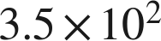 m by 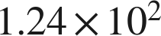 m. Find its area.

6. A car travels 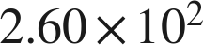 km in 3.0 hours. Find its average speed.

7. Two lengths are measured: 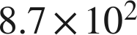 mm and 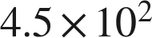 mm. Find their sum.

8. Two masses are measured: 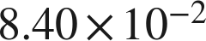 g and 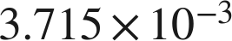 g. Find their difference.

Real quantities.
9. The Amazon River discharges about  gallons of water each second.
a. How many gallons does it discharge in one hour, which is  seconds? Report the answer with the correct number of significant digits.

b. A second river discharges about  gallons per second. How many times larger is the Amazon's rate? Report the answer with the correct number of significant digits.

10. A processor performs about 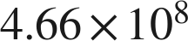 calculations each second.
a. How many calculations does it perform in one minute? Report the answer with the correct number of significant digits.

b. Five of these processors run for 20 minutes. How many calculations do they perform altogether? Report the answer with the correct number of significant digits.

Reading someone else's work.
11. Omar multiplies a measured length of 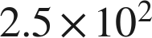 m by a measured width of 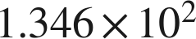 m and reports the area as 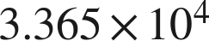 square meters. Is his arithmetic correct? Is his answer correct? Explain.

12. A rectangle's sides are measured as 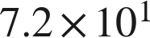 cm and 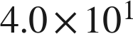 cm. Which is the area, in scientific notation with the correct number of significant digits?
○ A. 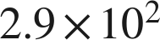 cm²
○ B. 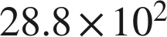 cm²
○ C. 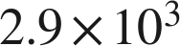 cm²
○ D. 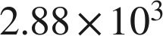 cm²

